Double clicking the software icon brings up an ‘e-tutor Information/Welcome’ page.

**The “e-tutor Info/Welcome” Page**

Details on the page

Links:

* **“About e-tutor”**: is a page that documents info about e-tutor with ‘*Exit’* and ‘*Login*’ buttons.
* “**About Cognitive”**: is a page that documents info about Cognitive and its team.
* **“Credits”**: is a page that mentions names of organisation, schools, institution and individuals that contributed to e-tutor.
* **“Clients”**: on this page is a list of e-tutor clientele.
* **“Login”**: comes up with a page that asks for login credentials of users.

**Note:** The desktop version should allow any users and create *“User History*” for each user just as in existing e-tutor, but the web/online/mobile version should authenticate users’ login credentials before proceeding to the *“e-tutor Home”* page.

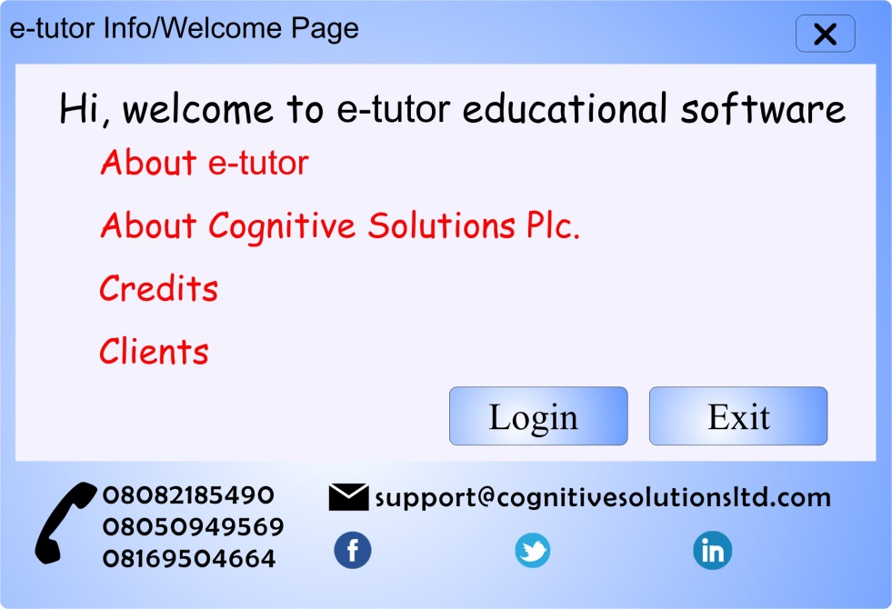

**N.B: “***Login*”, “*Back”* and “*Exit”* buttons must be placed on each of the pages above.

* **“Back”**: takes user to “*e-tutor Info/Welcome*” page
* “Exit”: leaves the page and returns users to the desktop.
* **“Login”:** takes users to *“e-tutor Home”* page.

**Please Note:** Every page of this software must contain Cognitive’s contact details as footer.

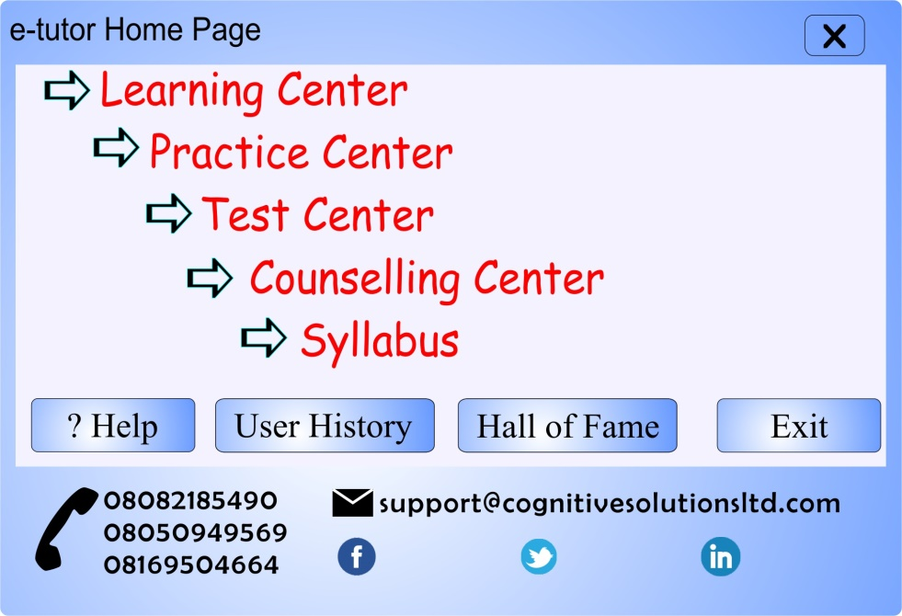

**The “e-tutor Home” Page**

This page retains e-tutor regular existing features such as “*Learning Center*”, “*Practice Center*”, “*Test Center*”, “*Counselling Center*” and “*Syllabus*”, and other buttons such as “*Exit*”, “*Help*”, “*User History*” and “*Hall of Fame*”.

“*Exit*”: the “*Exit*” button on this page should take users to the “*e-tutor Info/Welcome*” page.

“*Help*”: should open the “e-tutor Help” page with content on how to install and how to use and also how to get support.

Other buttons on this page maintains their respective functions as in the existing e-tutor.

**The “e-tutor Learning Center” Page**

From this page, and as seen below, a user will select his subject of choice by clicking on its button.

Menus on this page should include: Practice Center, Test Center, Counselling Center, Help and Exit.

“*Exit*” and “*Help*”:- function as designed on the “*e-tutor Home*” page.

“*Practice Center*”: - links to e-tutor Practice Center

“*Test Center*”: - links to e-tutor Test Center

“*Counselling Center*”: links to e-tutor Counsellor

Hovering a mouse over any subject reveals class categories of S.S.S 1, S.S.S 2 and S.S.S 3 (in the case of e-tutor SSCE School Version). If a user selects S.S.S 1, he is taken to a page that list Table of Content (TOC) for S.S.S 1 of the selected subject. Each listed topic in the “*TOC*” page is a link to its content inside the Learning Center Content Page. The “*TOC*” page has buttons “*Back*” (which returns users to the Learning Center Page), “*Exit*” (as designed), “*Home*” (which takes the user to “*e-tutor Home*” Page), and links “*S.S.S 2*” and “*S.S.S 3*” that lead a user to the “*TOC*” of the respective classes.

**N.B: “***TOC”* for S.S.S 1, S.S.S 2, and S.S.S 3 can actually exist on a single page, but each would be referenced by an anchor (something like <a href = “ ”) as existed in html codes.

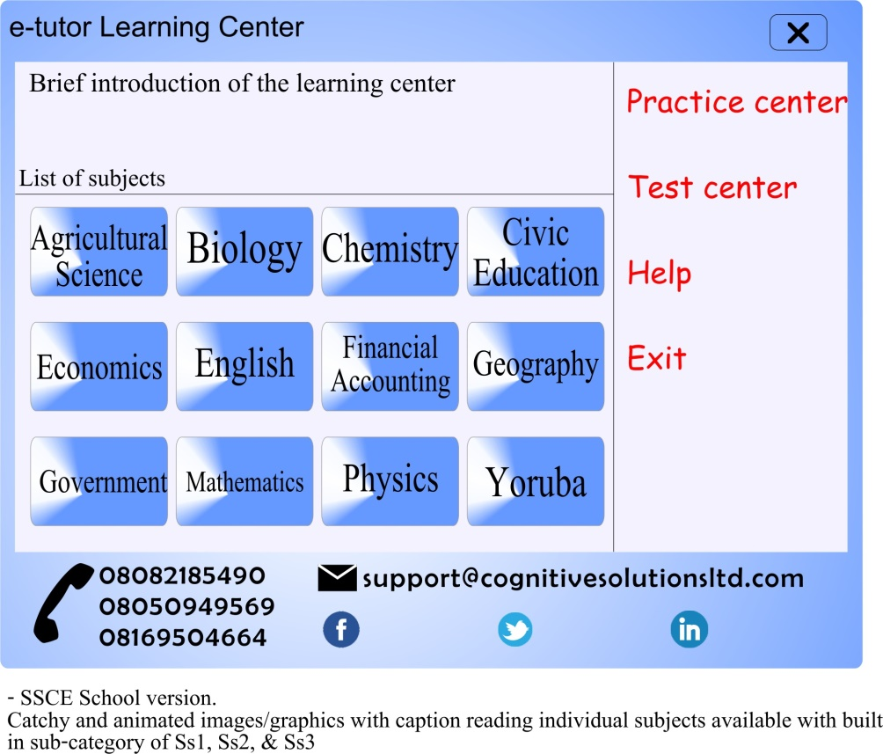

Selecting a topic on the “*TOC”* takes a user to the “Learning Center Content” Page depicted below.

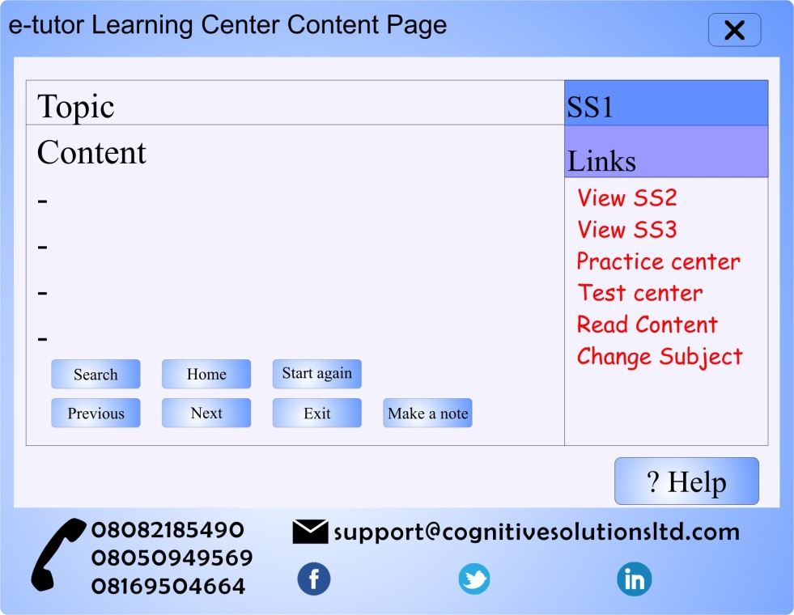

**The “Learning Center Content” Page**

“***Search***”: Performs search of user-inputed terms/concept related to the subject in view. When clicked on, a box with text field comes up. A user inputs his/her words to be searched inside the text field and then click on “*Ok/Search/Find*”. This search should return list of topics that are related to the searched term/concept or where the searched term/concept is being mentioned within the subject/class in view. If no match is found for the user-inputed term/concept/words, a prompt indicating such should be displayed. If a match is found, a list of the matched or found items will be displayed from which a user will select, and then click on “*View/Ok*” which now returns the user to “*Learning Center Content*” page.

“***Home***”: takes users to the “*e-tutor Home*” page.

“***Start Again***”: takes user back to the beginning of the current topic.

“***Previous***”: takes user to the previously read/viewed page.

***“Next”:*** takes user to the next page

***“Exit”:*** as designed, i.e. returns user to “*e-tutor Info/Welcome*” page.

***“Make a note”:*** calls up a text editor (Notepad or Word), in which a user can make jottings, that can be saved within the application, and also be called up for re-use and saved again. To eventually become the users note or key points within the software.

***“Help”:*** as designed, i.e. links to “*e-tutor Help*”

“***Read Content***”: calls up a text-to-speech machine that reads the content of the topic selected page by page.

***“Change Subject”:*** takes users to the “*Learning Center*” page in order to be able to select another subject.

***“Test Center”:*** Links to “*e-tutor Test Center*”

***“Practice Center”:*** Links to “e-tutor Practice Center”

“SS2 and SS3”: lets users jump from S.S.S 1 to either of S.S.S 2 or S.S.S 3. A click on either of these loads its TOC.

**The “e-tutor Practice Center” Page**

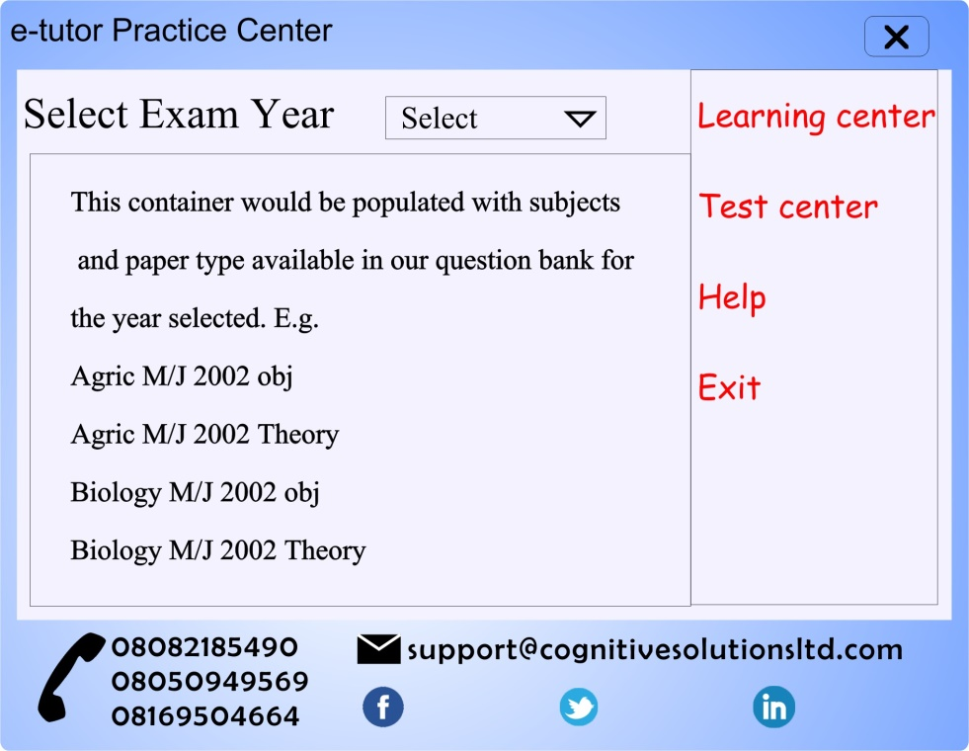

A selection on the page above takes user to the “*e-tutor Practice Center Content*” page shown belows:

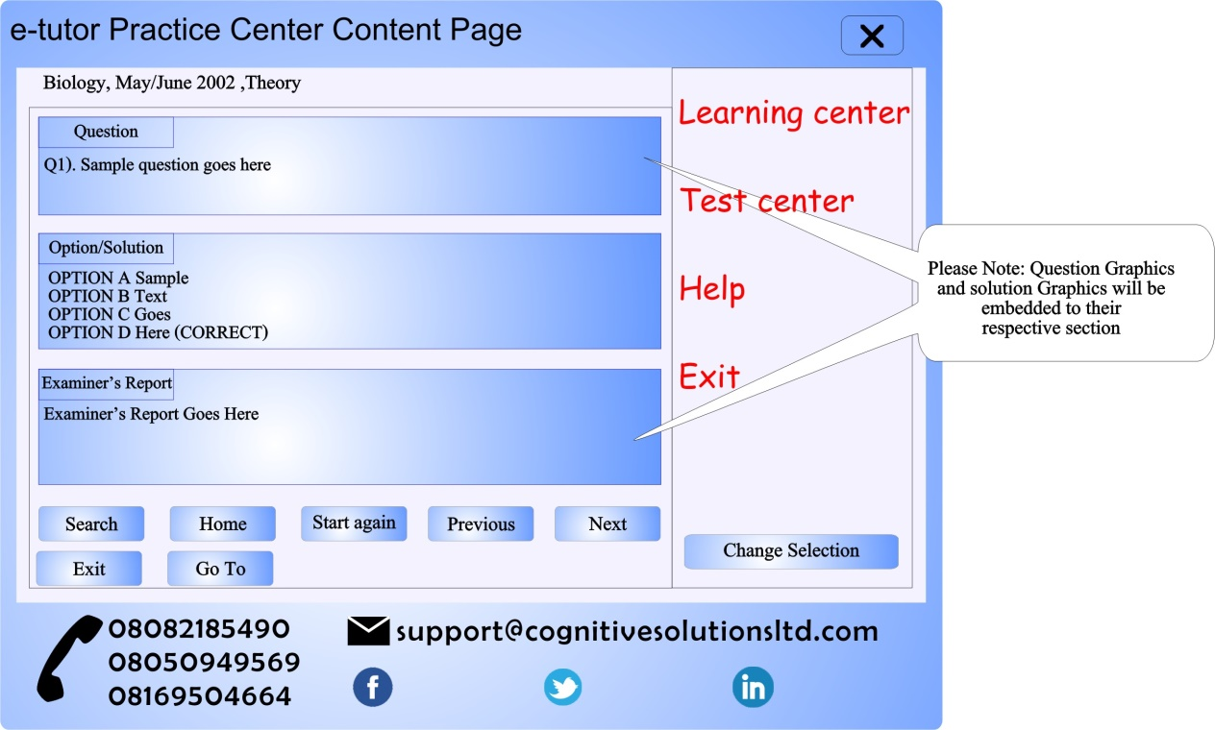

***“Search”:***performs a search of user-inputed term/word/concept that is related to the exam in view. Its work is similar to the one in the Learning Center Content page, but its search is only limited to the particular exam year in view.

***“Home”:*** takes users to “*e-tutor Home*” page.

***“Start Again”:*** returns users to the first question of that particular year i.e. Question 1

***“Previous”***: takes users to the previously viewed question.

***“Next”***: takes users to the next question

***“Exit”***: as designed.

***“Go To”***: allows users to jump to desired question number. For example, a user can jump to Question number 10 from Question number 3 by clicking on the “*Go To*” button, supply the question number and then click on “Ok”.

***“Change Selection”****:* returns users to “e-tutor Practice Center” page where the user can select another Year/Subject/Exam.

“Learning Center”, “Test Center”, “Read Content”, “Help”: all these links perform their respective functions as designed.

**The “e-tutor Test Center” Page**

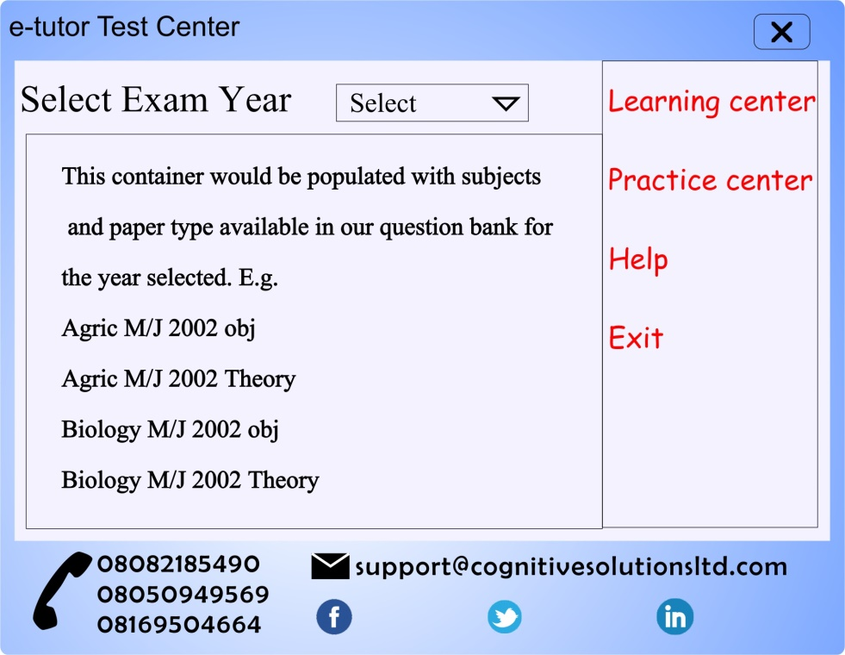

A selection on the Page above makes user to the “e-tutor Test timer” which allows user to set its own testing time just as is in current “e-tutor T.C”. An option to accept a default test time of 120minutes should also be available. Whatever the user’s preference here is, the user is taken to the testing machine below.

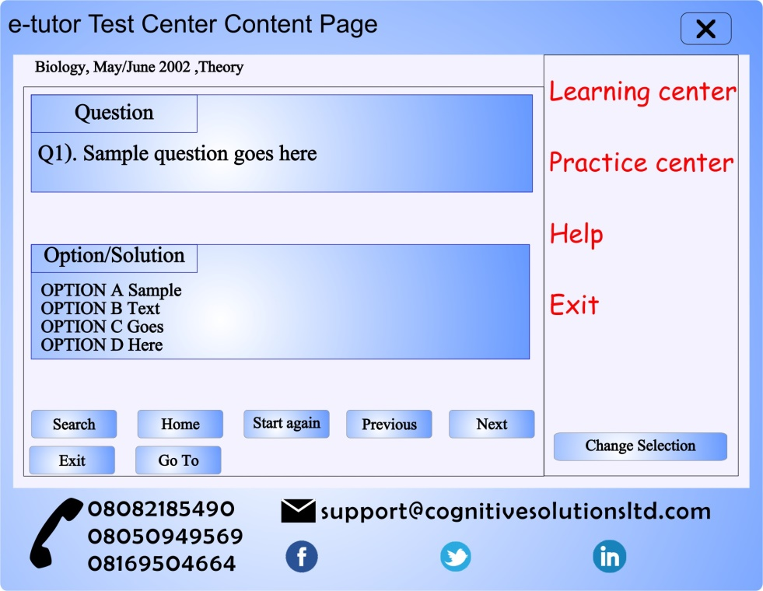

All the buttons here are also available on the Practice Center, and they perform the same functions as in the Practice Center.

**The “e-tutor Counselling Center” Page**

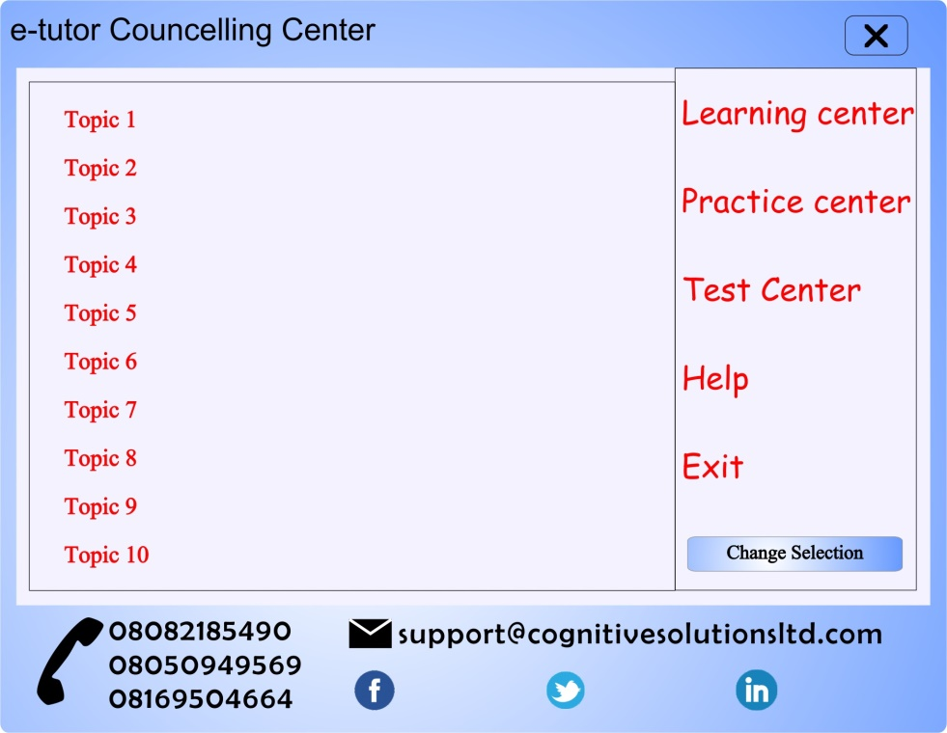

A selection on the page above will take the user to “*e-tutor Counselling Center Content*” page shown below.

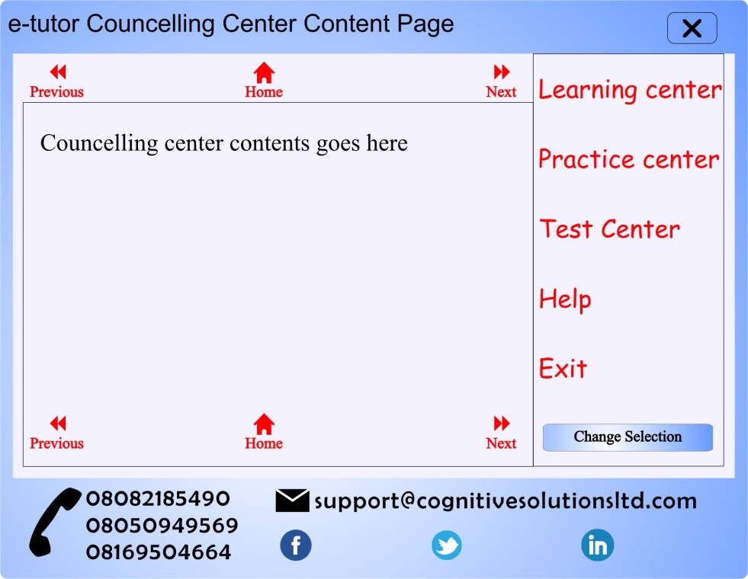

“*Previous*” and “*Next*” buttons are used for page navigation, while the “*Home*” button returns a user to “*e-tutor Home*” page.

**The “e-tutor Syllabus” Page**

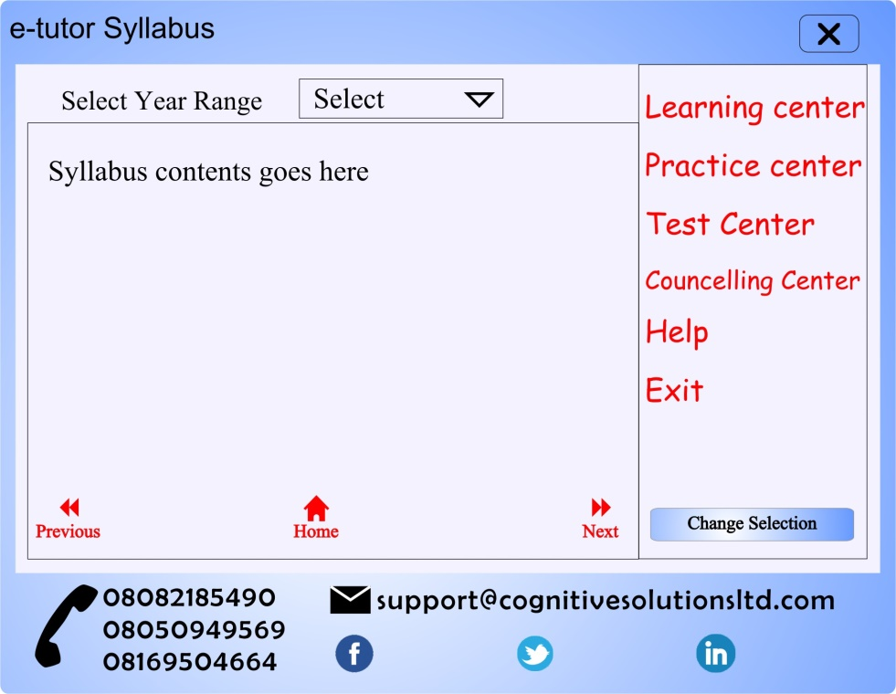

A user will select the year range, and its content will be displayed in the container right below the drop-down.

“*Previous*” and “*Next*” buttons are used for page navigation, while the “*Home*” button returns a user to “*e-tutor Home*” page. Other links work as designed and available on other pages.